Raju Jha | UX/UI Designer & Product Designer  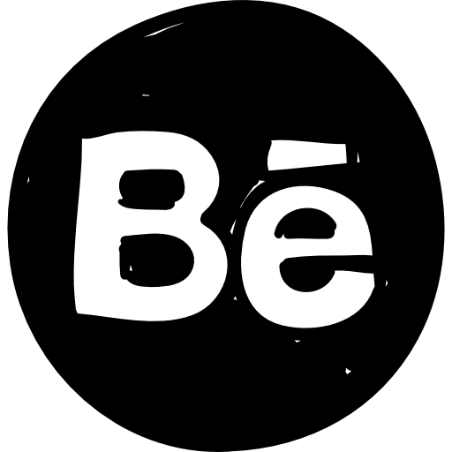 www.behance.net/rajujha www.rajujha.com

 | + 91-9990 140 744 |  | rajujha.designer@gmail.com |  | www.linkedin.com/in/rajujhadesigner

Summary
UI/UX designer & Product Designer, with 9.8 years of experience in designing and creating mockups, designs, and responsive HTML as per the customer requirement. Hands-on experience in designing screens for Mobile App (Android/IOS). Desirous of a similar role and position in a progressive organization that welcomes innovative ideas and utilizes my technical skills for the growth of the organization as well as to enhance my knowledge about the latest emerging trends.

Skill
- UX/UI Design | : | Adobe Creative Suite (Illustrator, Photoshop, InDesign, XD, Skala), Figma, Sketch, Wire-frame/Balsamiq, Prototyping, A/B Testing, Card Sorting, User Testing, Persona, Creation, Website UI Design, Style Guide, System Design, Atomic Design, CorelDraw XP, InVision, Ux Pin, Axure, Zeplin or Angular Material
- Web Technologies Tool | : | HTML5, CSS3, Bootstrap 4/5, Emailer Html, JQuery/JavaScript, Web Usability & W3 Web standards, Mobile Responsive, Using MVC/Asp.net, Angular Framework. Using Jira & Bit bucket
- Audio/Video Tool | : | Adobe After Effects, Adobe Premiere, FCP (Final Cut Pro), Video Editing, Compressor and Color

Experience
NEC Corporation India (Noida-India)  Technical Lead- UX/UI Designer |  | Aug 2019 to Present
- AltEd (Alternative Education)
- Involved in visual design, layouts, graphics development, typography colour schemes & HTML development for responsive screen designs.
- Actively involved in client meetings to capture the use case requirements, create requirement documents and screen designs in Adobe XD.
- Delivered several use cases, with no major bugs on UI and received client appreciations.

- Mentor-Marg
- Assisted the team in the planning and estimating of the design activities. Participating in broader workflow coordination and setting of expectations.
- Handled customer-facing roles & responsibilities to capture their interest and developed wireframes and prototypes according to their expectation.
- Designed logo, mailer templates & contributed to deciding the user flow by suggesting pixel-perfect design solutions to satisfy product requirements.

- VerifHire
- Created high fidelity prototypes to demonstrate application flow and design solutions.
- Iterate on existing application features to improve usability and drive key metrics.
- Suggested creative ways to solve UX problems and communicate design ideas and prototypes to product owners.

- MI-Eye (Guardian)
- Handled roles & responsibilities as UI/UX developer to fix existing failures & design new features for different screen sizes.
- Designed and created mailer templates, banners, icons & logos.
- Created responsive HTML screens using an angular material framework.

TV18 Home Shopping Network Ltd. (Noida - India)  Sr. UX/UI Designer | Dec 2018 to Aug 2019
- Involved in design and development of new features and research methods - usability testing.
- Actively involved in client communication to understand the product details and requirements.
- Experience in B2C solutions for the enterprise market desired.
- Applied design principles and documentation while working on various tasks.

Junglee Games India Pvt. Ltd. (Delhi - India)  Sr. UX/UI Designer | Feb 2018 to Nov 2018

- In order to use new technology platforms for my organization as well as clients, I have designed a mobile application.
- Interpreting project briefs to develop creative strategies for effective product promotion.
- End-to-end solutions right from scribble stage through interactions at regular intervals during ongoing projects and right up to final execution using various graphic software for online communication.
- Produce UI documentation, including specifications, page/design consistency, and a guideline.

Akhil System Pvt. Ltd. (Delhi - India)  UX/UI Designer | Sep 2015 to Aug 2017
- Facilitating the discussions and requirement gathering of existing workflow, daily tasks, and environment to clearly understand the user mental model.
- Creating design strategy & persona in sync with client’s brand values, measuring critical success factors, and making field studies by using various data gathering methods.
- Interact closely with development teams to provide the best overall technical solutions to meet product requirements.
- Design Android Applications for various brands- BLK Hospital, Jaipur Golden Hospital, etc.

Vijn IT Solutions Pvt. Ltd. (Delhi - India)  Sr. Web Designer | May 2014 to Aug 2015
- Design and create logos, print ads, mock-ups and presentation graphics in Photoshop and Illustrator.
- Created professional designs and layouts for promotional materials including direct mailings, handouts, advertisements, posters, logos, and other visual layouts.
- Created training materials using a combination of screen capturing, content arrangement, voice over and animation.
- Created high-quality client deliverables for both print and digital applications.
- Collaborated with other developers, instructional designers, and graphic artists to generate designs like templates, screen savers, frames & editing computer.

eAge Software Service Pvt. Ltd (Delhi - India)  Web Designer | June 2012 to May 2014

- Created graphics, GIF- animations, illustrations, webpages with Html page.
- Designed UI and created modules to make learning convenient and effortless.
- Generated designs like templates, screen savers, frames & editing computers.
- Contributed to and maintain design pattern libraries and standardize design language cross all products.

Educational
- Graduation B.A (P) from (Delhi University) in Delhi - (2005 to 2008)
- Senior Secondary from (CBSE Board) in Delhi - (2004 to 2005)
- Secondary from (CBSE Board) in Delhi - (2002 to 2003)

Certificate
- Certificate in UX Designing Certificate Course (Baagdi Solutions Pvt. Ltd.) - (Sept 2022)
- 6 Months Certificate in Design Thinking: The Beginner’s Guide, Interaction Design Foundation (IDF Institute), - (Sept 2020)
- Two Years Certificate in Multimedia Animation, Animation & Digital Education Center (ADMEC Institute), Rohini – Delhi (2009-10)
- 6 Months Certificate in Basic Computer Course, Viklang Sahara Samiti Delhi (V.S.S.D. Institute) Govt. Regd. Delhi (2005)

My Concept
Genius begins great work, can work alone & finishes it.

Personal Details
Father’s Name | : | Sh. Bimlesh Jha
Date Of Birth | : | 26th Feb 1986
Languages Known | : | English & Hindi
Strength | : | Honest & Hard working
Hobbies | : | Reading, Music Movie, Game, Travel & Watching etc.

Date : ____/____/_______
Place : _________________ | (RAJU JHA)

